**Recursive Mean-Separate Histogram Equalization (RMSHE)**

This technique is introduced in 2003. In this technique, the histogram of the original image is devided into 2^t sub-histogram, whereas t is an integer number. Then each sub-histogram is equalized separately. This method can preserve the intensity by it's recursive charachteristics. Increasing t, the mean of intensity is protected more but the contrast improved less.

The figure bellow shows this method for t=2.

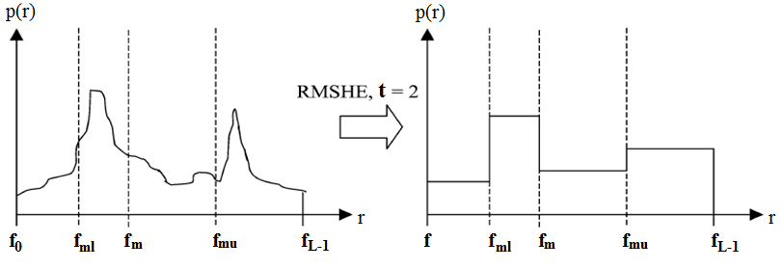

Reference:

[Kau11]  
Kaur.M, Kaur.J (2011), "Survey of contrast enhancement techniques based on histogram equalization", International Journal of Advanced Computer Science and Applications(IJACSA), Vol: 2, No: 7, PP: 137-141.